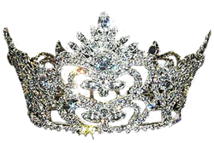
KEEP TO ONE PAGE Insert photogenic headshot
Name: Click here to enter text.
Age: Click here to enter text.
Parents(s)/Guardian(s): Click here to enter text.
Hometown: Click here to enter text.
School/Grade: Click here to enter text.
Favorite Subject: Click here to enter text.
Favorite Food: Click here to enter text.
Favorite Color: Click here to enter text.
Hobbies and Activities: Click here to enter text.
What do you want to be when you grow up: Click here to enter text.

Do not write below this point, for official judges’ use only
Scoring is based on a scale of 1-10 (1 being the lowest and 10 the highest) highest total point’s wins
Beauty | Stage Presence | Wardrobe | Personality | Answer to Question | Total

