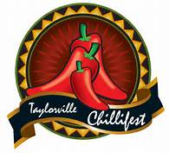
As a parent or legal guardian of a participant in the a 2017 Chilli Pepper contestant; I assume the full responsibility for any injury, damage, or loss which may be sustained as a result of participating in any manner associated with this program. I further agree to waive, release and relinquish any and all claims which may result from participating in this contest against the chillifest board, sponsor, coordinators, volunteers, or helpers. Judges scores will not be released or discussed
I understand that the judges’ decision is final. I agree to the use of photos of my child for promotional purposes only on the official Taylorville Chilli Pepper Pageant facebook and in the local newspapers. I also agree to not coach my child or try to take photos from behind the judges, thus distracting the judges and official pageant photographer.

Parent of legal guardian signatures
Signature Date
Signature Date
Signature Date
Signature Date

